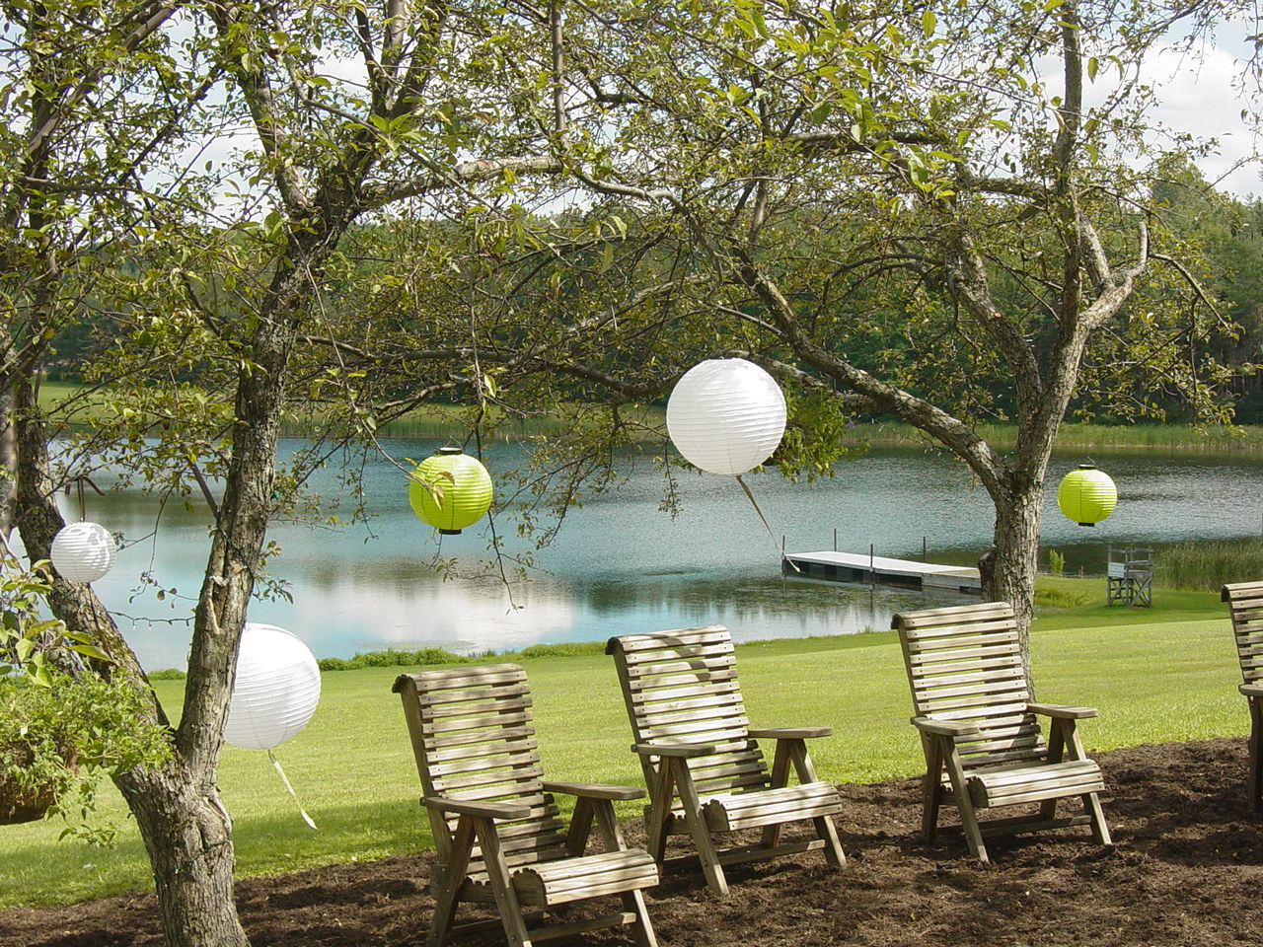

Alfred State Dining Services
Catering with A Touch of Class

Phone: (607) 587-4095, (607) 587-4037 * Fax: (607) 587-4339
Email:shuttme@alfredstate.edu or middletj@alfredstate.edu

A r r a n g e m e n t 1

At Auxiliary Campus Enterprises and Service (A.C.E.S), we would like to help you plan your special event so that it is a memorable and enjoyable occasion. This brochure is presented as a guide in planning all types of affairs, but please remembers these are only suggestions. The possible ways in which we can serve you are flexible and limited only by your imagination and budget. We are here to serve you and take pleasure in doing just that. Our goal at A.C.E.S. is to provide you with a full range of quality and innovative catering services by our service-oriented staff.



G u i d e l i n e s 2

Reservations for the area in which you desire to hold your function must be reserved with the A.C.E.S. Office by calling Tracie Middleton at (607) 587-4037. To be assured of obtaining the area of your choice, we suggest that you call as soon as you know the date and time of your function.
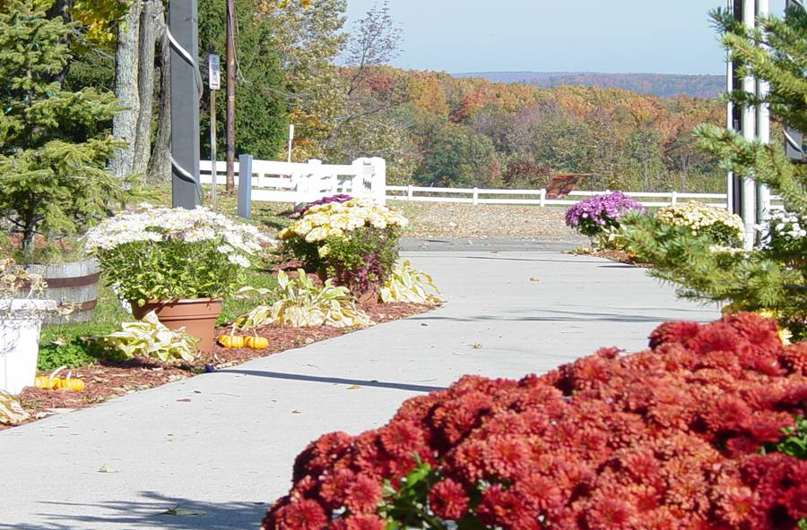
Once your area has been reserved, please contact the Special Events Manager at (607) 587-4095 to begin your planning process. We request three (3) weeks notice for dinners, luncheons, and small banquets. Large banquets and receptions require at least 30 days’ notice. Coffee breaks will be accepted three (3) business days in advance.

In order to be properly prepared to host your function, it is essential that we be informed of your estimated attendance count fourteen (14) days prior to your event, and guaranteed attendance at least 7 (7) business days prior to the function. Once this number is received, reductions cannot be made in the number. We will prepare and order for an additional 5%. However, the number guaranteed will be charged in full even if fewer guests attend. In the event that no guarantee is given, the expected number as listed on the Banquet Event Order will be used.
We may accept events booked inside of the (5) days window. However, we will not be able to guarantee products because of delivery schedules. A late fee may be assessed in order to cover additional costs.
All prices are subject to New York State Tax where applicable. If you are tax exempt, please submit a copy of your tax-exempt certificate prior to your event.
A Minimum of $100.00 will be charged to groups canceling on less than 15 days’ notice. Any additional cost incurred as a result of such cancellation will also be billed to the group.

G u i d e l i n e s 3

- Beverages for meals include coffee, tea, and decaffeinated coffee. Food leftovers are returned to A.C.E.S. as 10-20% overage is produced in the event of over attendance. All food and beverages must be served by staff of A.C.E.S.
- A 50% deposit on estimated costs will be due 30 days in advance of your event for wedding reception, dinners, and banquets.
- There is a two keg limit on all functions. Non-alcoholic beverages will be served at all functions where alcohol is served.
- Functions requiring a cash bar service outside of Central Dining Hall require a fee of $60.00 to obtain a liquor permit. Open bar functions do not require this.
- When your function is over, the bar closes. There is a four-hour limit on your event starting after dinner.
- All guests wishing to consume alcohol must be 21 years of age and have a picture ID to prove it.
- Bar Service Options: Hosted Open Bar, Set Tab/Consumption Bar (Host set a limit amount) or Cash Bar. None alcoholic beverages included in your meal price.
- Any and all alcohol at any function will be provides solely by A.C.E.S.
- No outside personal purchases alcohol is to be brought into the event or consumed on the Lake Lodge property, violation of this will result in your event being shut down.

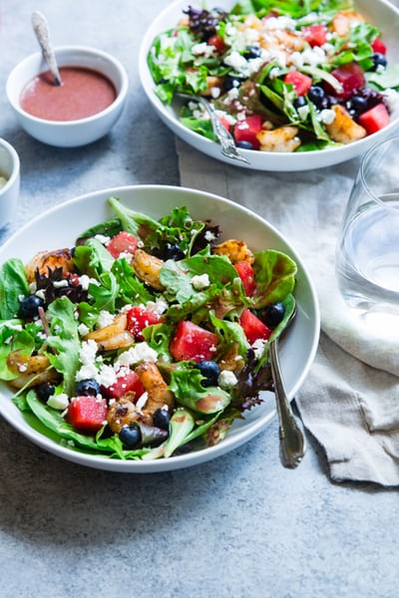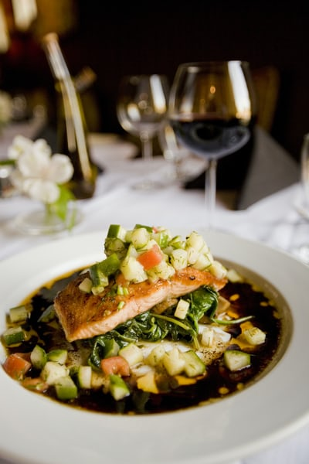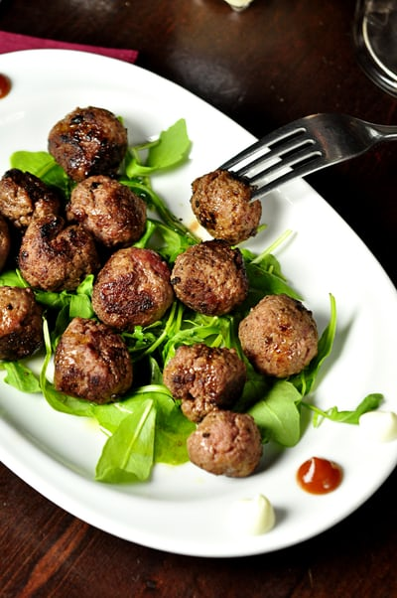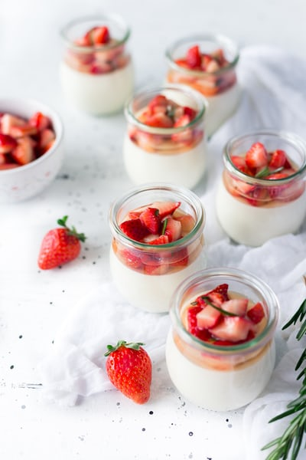
H o r s D’o e u v r e s 4

Served Cold:
Price per 100 pieces

Bruschetta $85.00 Presentations (per guest)
Deviled Eggs $85.00 Fresh Vegetables and Dip $1.85
Beef Carpaccio $125.00 Party Bread Loaf with Dip $1.50
Fresh Jumbo Shrimp Cocktail $165.00 Cheese & Crackers w/ Pepperoni $2.00
Finger Sandwiches $115.00 Fresh Seasonal Fruit w/ Dip $1.85
Charcuterie $5.00

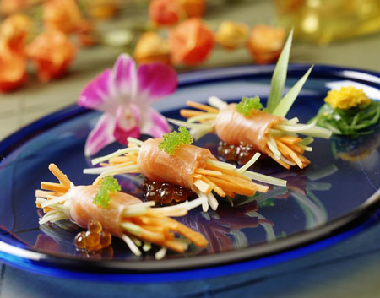

Served Hot:
Price per 100 pieces

Mushroom Vol au vent $140.00 Pot Stickers $120.00
Sweet Chili Meatballs $120.00 Chicken Cordon Bleus Bites $140.00
Chicago Pizza Bites $115.00 Petite Beef on Weck $350.00
Stuffed Mushrooms (sausage) $130.00 Hot Spinach and Artichoke Dip
Marinated Beef Kabobs $230.00 served with Assorted Crackers $85.00
Hawaiian Chicken Kabobs Mini Beef Willington $300.00
with Pineapple $190.00 Chicken Wings $225.00

Buffet Dinner Option 5

Entree Options :
Artichoke Chicken Parmesan Bruschetta Chicken
Herb Crusted Roast Beef Chicken Cordon Bleu
Sage Roasted Turkey Breast Citrus Tilapia
Haddock Filet Jack Daniel’s Flank Steak
Chicken Marsala Stearns Chicken Breast
Maple Glazed Ham Garlic Crusted Pork Loin

Side Options :
Red Skinned Mashed Potatoes Pasta Primavera
Fettuccine Alfredo Cilantro-Lime Rice
Penne Rigate Potato Au Gratin
Orange Herbed Rice Lemony Pasta with Arugula
Baby Red Roasted Potatoes Baked Ziti
Macaroni and Cheese Southern Revival Sweet Potatoes

(A Seasonal Vegetable will accompany the Entrée)

Dinner Rolls:
Artisan
White Mountain
Mini Corn Bread Loaf

Pre-Set Salad:
Spring Mixed Salad
Spinach-Strawberry Salad
Fresh Chopped Romaine Salad
Romaine Heart w/ Bacon
Caesar Salad

Buffet starting at $39.95 per person
D e s s e r t s 6

$2.25 per person
Apple Pie Fresh Fruit with Crème Anglaise
Top Your Own Pound Cake Angel Food Cake with Assorted Fruit Topping
Chocolate Mousse Assorted Cookies
Pumpkin Pie Frosted Chocolate Brownies
Cherry/Blueberry Pie Chocolate Cake
Lemon Meringue Pie Assorted Dessert Bars

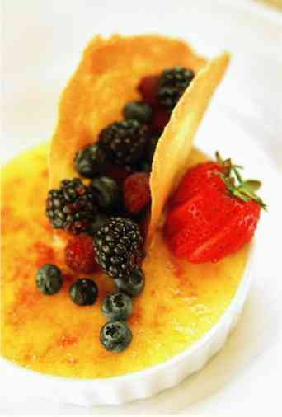
Available for an additional charge of $3.50 per person:

Carrot Cake Peanut Butter Pie
Strawberry Shortcake Oreo Cookie Bash
Chocolate Lovin’ Spoon Cake Heath bar Pie
Snickers Bar Pie S’more Bar
Deep Dish Berry Pie Cheesecake with Assorted Topping

